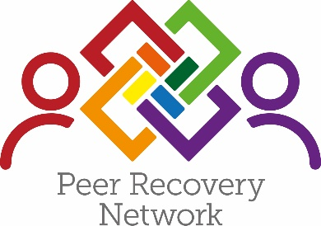
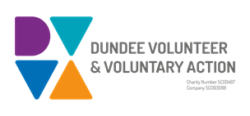
Lived Experience Network
Test of Change – Proposal
Background
In response to the Dundee Partnership commissioning their own independent Drug Commission Report in 2018, due to the high rate of drug deaths within Dundee, it was highlighted through the 16 recommendations in 2019, that it was critical that individuals with direct or indirect lived experience of substance/alcohol use, should be at the forefront of making decisions and improving services that would be meaningful to them. There is also a need to break down the barriers and challenges individuals face with recovery and progression into employment or training.
In 2019, the Peer Recovery Network was funded by the ADP to employ 3 peer workers all of whom are in recovery, in development posts. The post holders have opportunities to develop their skills whilst on placement with partner agencies and obtain their SVQ in Health and Social Care level 3. These posts have been funded for a period of 2 years ending 31st March 2021.
The Peer Recovery Network also recruits volunteers with lived experience to progress into employment or training and raise awareness of stigma in the community. This is achieved through community events, placement opportunities and peer training.
Test of change proposal
The proposal is to build on the Peer Recovery Network’s current engagement with people who have lived experience by increasing its range of engagement activities with individuals in Dundee. This will be achieved by establishing a Lived Experience Network where individuals can sign up to the network, and take part in various activities that will provide them with a voice in decision making and shape services going forward, tying in with the development of local and national strategies where applicable.
It is important that the involvement of people with lived experience is not tokenistic, therefore it is critical that individuals are listened to and their contributions are valued and they are kept informed of outcomes of all meetings, along with the option to opt in and out of the network .The possibility of developing a Lived Experience Quality Assurance Group, linked to ADP decision making will be explored (see Appendix 3)

Subject to Scottish Government funding, this development will be supported by:
- Recruiting 3 new peer workers with lived experience to development posts
- Recruiting individuals for the Lived Experience Network to ensure that the involvement of participants with lived experience is embedded effectively and meaningfully across the ADP and other decision-making structures.
- Supporting the delivery of two development sessions each year to bring together participants who support families and service providers to share information and test progress.
- Enabling participants to opt in and out of activities when they chose without judgement.
- Working in partnership with mental health services to ensure a better-connected approach to meet the needs of the individual with lived experience.
- Working in partnership with agencies in Dundee to provide a cohesive approach and prevent duplication.
- Providing a range of engagement opportunities to accommodate different peoples’ lived experience, lifestyles, and commitments, and preferences.
- Ensuring that the Lived Experience Network is independent, so that participants have ownership of the progression and shaping of decision making.
- Ensuring that participants understand that their voices are being heard and taken seriously and feedback is provided through appropriate media.
- Supporting and encouraging families to be involved and participate in developing the Lived Experience Network
The outcomes to be achieved include:
- Improved support for individuals with lived experience to participate in decision making across Dundee
- More peer recovery opportunities supported by appropriate learning and development
- Improved engagement and retention of lived experience within the whole system of care
- Individuals with lived experience are involved in shaping the design, delivery and monitoring of the Recovery Oriented System of care
- Service providers and stakeholders report more meaningful engagement with participants

Outcomes/impact will be measured using:
- Numerical data of participants signing up to the lived experience network
- Numerical data of participants attending training and attending capacity building opportunities
- Qualitative data on peoples experience of participating in decision making and having their voices heard
- Participants undertaking accredited personal development. e.g. obtaining certificates for training coursed, Adult achievements Awards, Health Issues in the Community, Naloxone awareness
- Numerical and qualitative date on participants progression into positive outcomes eg: volunteer, peer support, training or employment
- Feedback through recovery stories, evaluations and participants feedback
Resources required:
- Effective networks
- Funding for development and outreach work
- Training for participants to develop their understanding of how to influence policy and practice.
- Access to safe premises across the city for participants to meet which are friendly and accessible.
- Peer workers to support the network and record shared stories.

